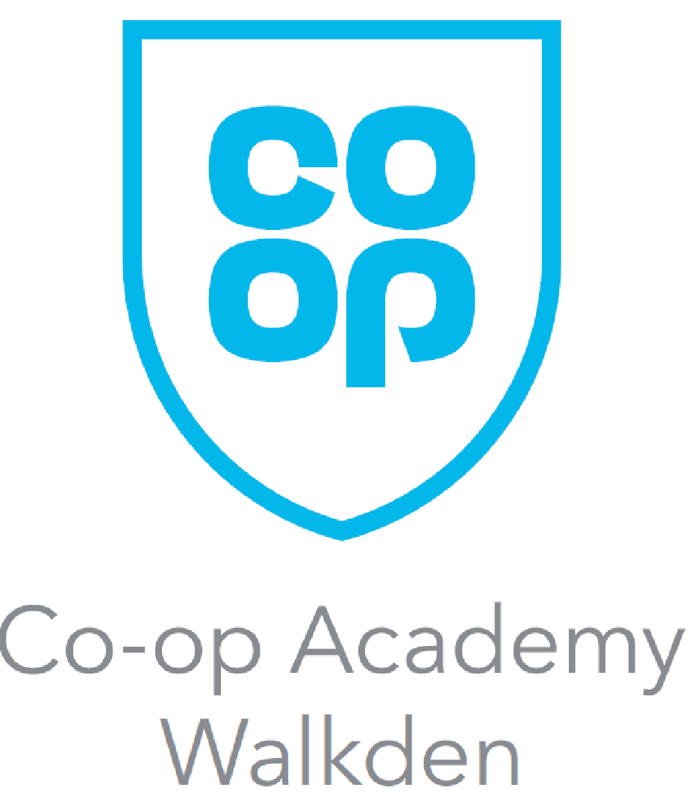
Week A Menu
Monday  - Large hotdog, onions & fries  - Cheeseburger, onions & fries  - Pasta Bake with garlic bread (V)(H)  - Pasta Sauce with garlic bread (VE) | Tuesday  - Chicken strips or BBQ pulled pork on a brioche bun with salad  - Mediterranean vegetable bake with garlic bread (V)(H)  - Chicken Balti Curry & Rice
Wednesday  - Fish fillet, chips & mushy peas  (H)  - Beef Lasagne, salad & garlic bread  - Vegetarian Lasagne, salad & garlic bread (V)(H) | Thursday  - Chicken fried rice / Beef fried rice  - Vegetable fried rice (V)(VE)(H)  - Chicken tikka curry with rice & naan bread
Friday  - Chicken Wrap, wedges & salad  - Quorn wrap, wedges & salad  (V)(H)  - Pasta & Basilico Sauce (V)(VE)(H) | Daily  - Selection of sandwiches & wraps  - Cold pasta pots  - Jacket potatoes with various filings

V - Vegetarian / VE - Vegan / H – Halal

Week B Menu
Monday  - Boneless Flavoured wings, wedges & corn on the cob  - Quorn fillet, wedges & corn on the cob (V)(VE)(H)  - Chicken tikka curry & rice | Tuesday  - Chicken Chow Mein  - Spaghetti Bolognese (H) / Pasta & Meatballs  - Vegetarian Spaghetti Bolognese (V)(VE)(H)
Wednesday  - Hunters chicken, diced potatoes & peas  - Quorn fillet, diced potatoes & peas  - Vegetarian Curry & Rice (V)(VE)(H) | Thursday  - Chicken Fajita served with Potato Wedges. Wrap, Salad & Mayo  - Vegan Fishless Fingers served with Chips, Peas, baked beans (V)(VE)(H)  - Chicken, Bacon Pasta
Friday  - Chicken burger, fries & salad  - Quorn fillet burger, fries & salad (V)(H)  - Beef Rogan Josh curry & rice | Daily  - Selection of sandwiches & wraps  - Cold pasta pots  - Jacket potatoes with various filings

V - Vegetarian / VE - Vegan / H – Halal

Lunchtime Extras  Sandwiches from £1.95  Baguettes from £2.10  Salad box with filings £2.10  Panini’s - Cheese & tomato (V)(H) £2.02  Panini’s - Cheese & ham £2.02  Main Meal only £2.10  From Menu A or B  Meal Deal option £2.20  Includes any main meal, sandwich or jacket potato & 1 dessert item  Please note the meal deal does not include water; however, drinking water is available to all students from the water fountains.  We recommend you bring refillable water bottles for throughout the day. | Morning Menu  Buttered Bagels - free to all pupils between 8am - 8.25 each day  Toast (per slice) (V)(H) 29p  Sausage or Bacon Petit Pan 92p  Croissant (V)(H) 99p  Pain au chocolate (V)(H) 99p  Pancakes x 2 (V)(H) 85p  Hash browns x 1 (break only) (V)(H) 29p  Hash browns x 3 (break only) (V)(H) 85p  Beans on One Toast (Breakfast only) (V)(VE)(H) 85p  Scrambled Egg One Toast (Breakfast only) (V)(H) 95p  Beverages  Bottled Water 500ml 85p  Milk Cartons 72p  Desserts/Biscuits/Muffins  Refer to daily menu boards for the allergens for  Jelly/Yoghurt 78p  Fresh Fruit (V)(VE)(H) 64p  Fruit salad pot (V)(VE)(H) 99p

V - Vegetarian / VE - Vegan / H – Halal
Theme Days
Please note on occasions, menus may be subject to change.  Look out for theme day posters. | May  Wednesday 20th May 2026  BBQ Feast  BBQ Sticky Chicken  BBQ Teriyaki Tofu  Both served with French fries & salad  Hot Brownies or Ice cream
June  Friday 5th June 2026  World Ocean Day  Vegan Fishless Finger Sub with salad & wedges  Fish Goujons with wedges & beans  Jam & coconut sponge & custard | July  TBC  Summertime Lunch  Selection of Chicago town pizza’s & fries  Chicken fillet Burger & fries  Choice of ice cream or lolly

